Linux commands End-to-End cheat sheet.
Shaikh Shahbazz

Command : whoami

Command : ls

Command : ip a
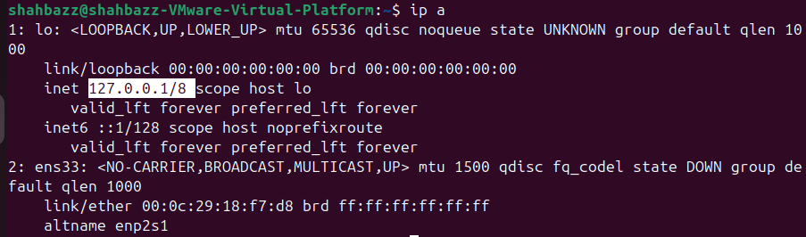

Command : cat
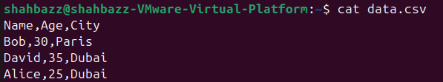

Command : passwd
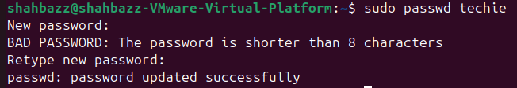

Command : touch
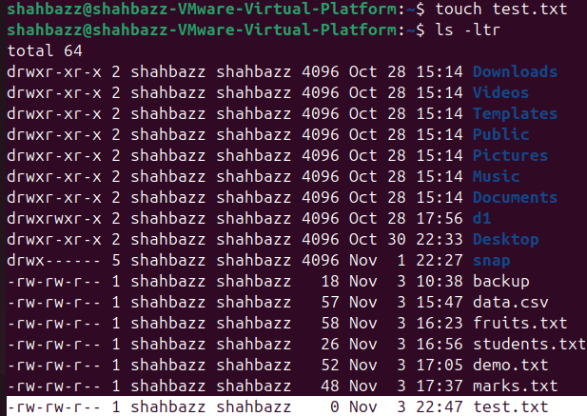

Command : pwd

Command : man
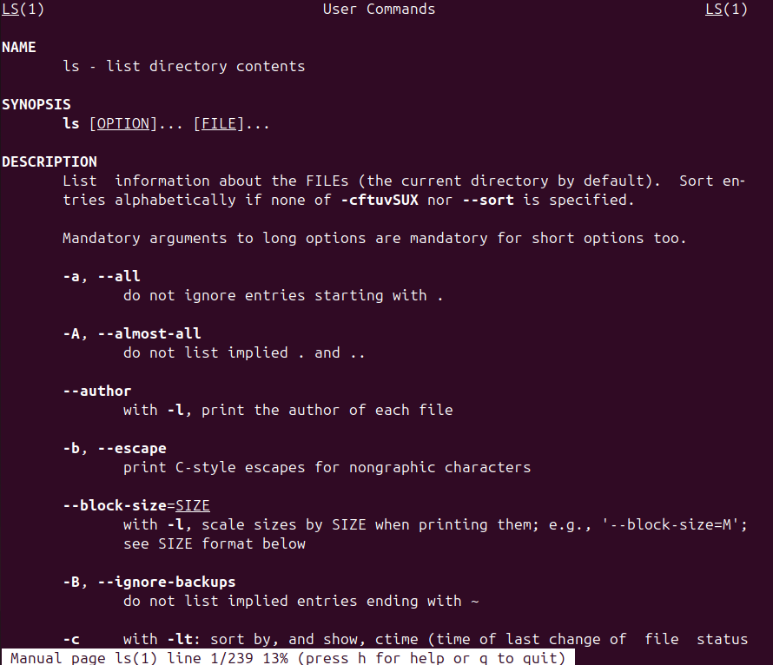

Command : apropos
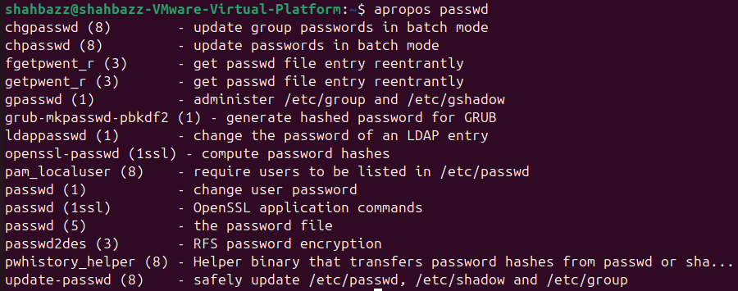

Command : pinfo
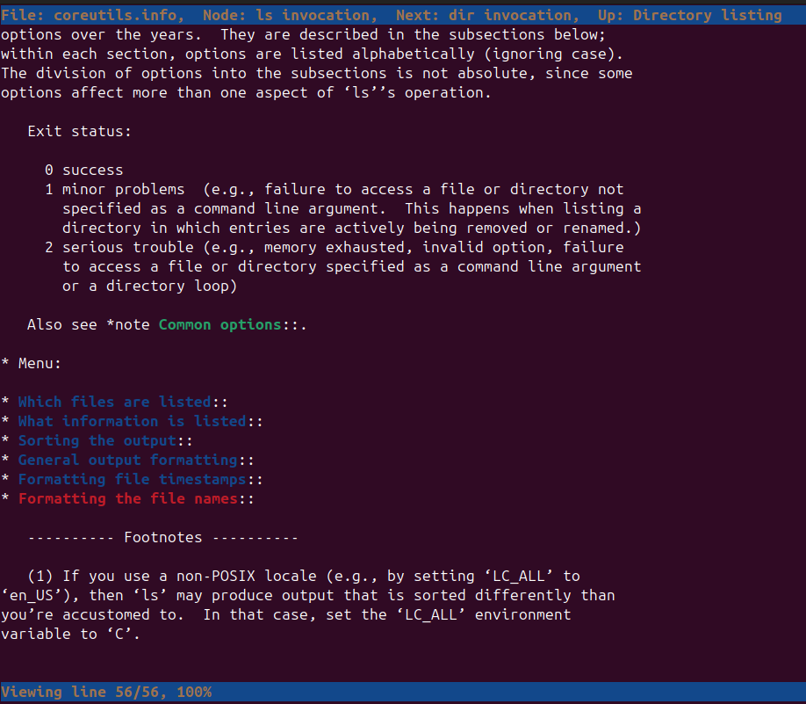
Command : t1dr and t1dr passwd
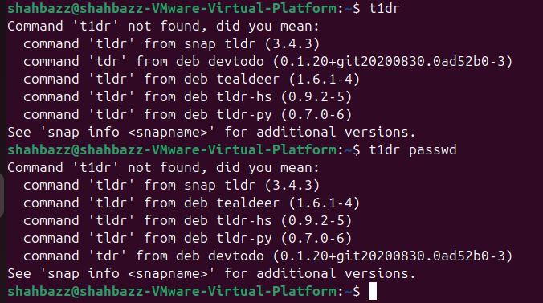
Essential file management tools.

Command : ls

Command : cp
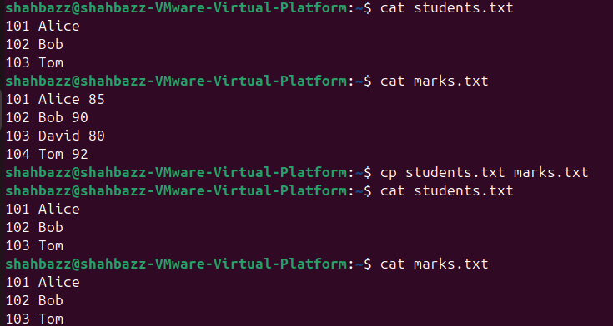

Command : mkdir

Command : rmdir
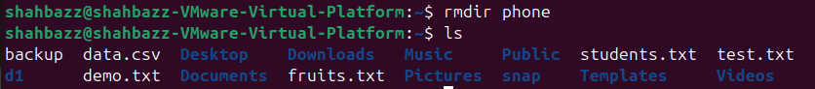

Command : mv
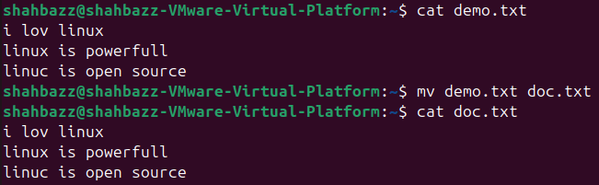

Command : rm
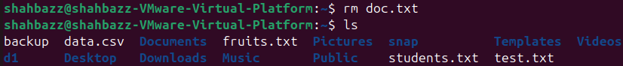

Command : rm -rf ----[comined -r (recursive) and -f(force) deletes directories and files without asking for permissions]
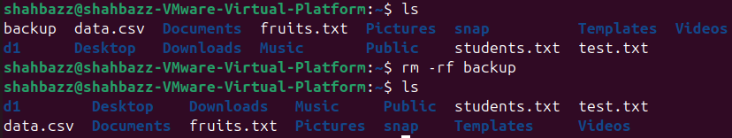

Advanced file management tools commands.

Command : ln ---creates hardlink to same files (Same inode).
